UNITED STATES
SECURITIES AND EXCHANGE COMMISSION
Washington, D.C. 20549

SCHEDULE 14A

Proxy Statement Pursuant to Section 14(a) of the Securities
Exchange Act of 1934 (Amendment No. )

Filed by the Registrant ☒

Filed by a party other than the Registrant ☐

Check the appropriate box:

☐ |  | Preliminary Proxy Statement
☐ |  | Confidential, for Use of the Commission Only (as permitted by Rule 14a-6(e)(2))
☐ |  | Definitive Proxy Statement
☒ |  | Definitive Additional Materials
☐ |  | Soliciting Material Pursuant to §240.14a-12

HOWARD HUGHES HOLDINGS INC.
(Name of Registrant as Specified In Its Charter)

(Name of Person(s) Filing Proxy Statement, if other than the Registrant)

Payment of Filing Fee (Check all boxes that apply):

☒ |  | No fee required.
☐ |  | Fee paid previously with preliminary materials.
☐ |  | Fee computed on table in exhibit required by Item 25(b) per Exchange Act Rules 14a-6(i)(1) and 0-11.

HOWARD HUGHES HOLDINGS INC.

On August 19, 2026, Howard Hughes Holdings Inc. (“HHH”) filed a definitive proxy statement (the “2026 Proxy Statement”) with the Securities and Exchange Commission (the “SEC”) in connection with its 2026 Annual Meeting of Stockholders (the “Annual Meeting”) to be held on September 30, 2026.

On September 25, 2026, William A. Ackman, Executive Chairman of HHH, posted the following post on X.com regarding the Annual Meeting:

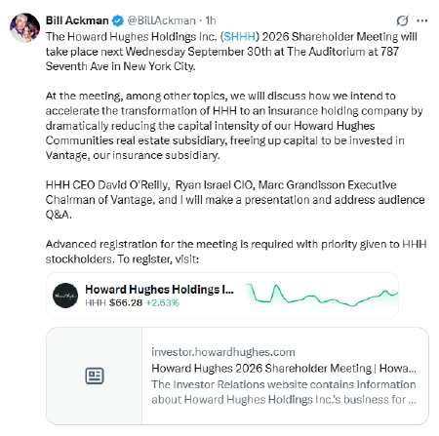

* * *

Also on September 25, 2026, HHH issued the following press release regarding the Annual Meeting:

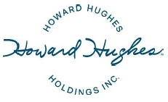

REMINDER: HHH 2026 ANNUAL SHAREHOLDER MEETING SET FOR SEPTEMBER 30

Meeting to begin at 9 a.m. ET at 787 Seventh Avenue in New York City

THE WOODLANDS, Texas, September 25, 2026 – Howard Hughes Holdings Inc. (NYSE: HHH) (the “Company”) reminds shareholders and interested members of the public that its 2026 Annual Shareholder Meeting will be held Wednesday, September 30, 2026, at 9 a.m. ET at 787 Seventh Avenue in New York City.

HHH Executive Chairman Bill Ackman will be joined by HHH CEO David O’Reilly, CIO Ryan Israel, and Executive Chairman of Vantage Marc Grandisson for an update on the business and audience Q&A. Discussions will include plans to accelerate HHH’s transformation into a diversified holding company, including efforts to significantly reduce the capital intensity of Howard Hughes Communities, the Company’s real estate subsidiary, and increase capital available for investment in Vantage, the Company’s insurance subsidiary.

The meeting is open to the public, with advance registration required. Priority will be given to HHH stockholders. Only HHH stockholders of record as of August 17, 2026, will be entitled to vote at the meeting.

The 2026 Shareholder Meeting may be attended in person or via live webcast. To register and view event details, visit https://shareholdermeeting.howardhughes.com/.

About Howard Hughes Holdings Inc.

Howard Hughes Holdings Inc. (NYSE: HHH) is a diversified holding company focused on growing long-term shareholder value. Its principal subsidiaries are Vantage Group Holdings, a leading specialty insurance, reinsurance, and partnership capital platform, and Howard Hughes Communities™, one of the nation’s leading real estate platforms. HHH brings together long-duration capital, high-quality operating businesses, and disciplined capital allocation to build long-term value. For additional information visit www.howardhughes.com.

Forward-Looking Statements

Statements made in this press release that are not historical facts, including statements accompanied by words such as “anticipate,” “will,” “believe,” “expect,” “position,” “assume,” and other words of similar expression, are forward-looking statements within the meaning of the Private Securities Litigation Reform Act of 1995. These statements are based on management’s expectations, estimates, assumptions, and projections as of the date of this release and are not guarantees of future performance. Actual results may differ materially from those expressed or implied in these statements. Factors that could cause actual results to differ materially are set forth as risk factors in Howard Hughes Holdings Inc.’s filings with the Securities and Exchange Commission, including its Quarterly and Annual Reports. Howard Hughes Holdings Inc. cautions you not to place undue reliance on the forward-looking statements contained in this release. Howard Hughes Holdings Inc. does not undertake any obligation to publicly update or revise any forward-looking statements to reflect future events, information or circumstances that arise after the date of this release.

Investor Relations:

investorrelations@howardhughes.com
281-929-7700

Media Relations:

press@howardhughes.com
281-929-7700

Forward-Looking Statements

These materials contain forward-looking statements within the meaning of Section 27A of the Securities Act of 1933, as amended, and Section 21E of the Securities Exchange Act of 1934, as amended. Forward-looking statements are not guarantees of future performance and are subject to risks, uncertainties and other factors, many of which are beyond HHH’s control, that could cause actual results to differ materially from those expressed or implied, including those described under “Risk Factors” in HHH’s Annual Report on Form 10-K for the fiscal year ended December 31, 2025 and its Quarterly Report on Form 10-Q for the quarter ended June 30, 2026. Forward-looking statements speak only as of the date they are made, and HHH undertakes no obligation to update them except as required by law.

Important Additional Information and Where to Find It

HHH has filed the 2026 Proxy Statement and accompanying proxy card with the SEC on August 19, 2026 in connection with the solicitation of proxies for the Annual Meeting. STOCKHOLDERS ARE STRONGLY ENCOURAGED TO READ THE 2026 PROXY STATEMENT (INCLUDING ANY AMENDMENTS OR SUPPLEMENTS THERETO), THE ACCOMPANYING PROXY CARD AND ANY OTHER RELEVANT DOCUMENTS FILED BY HHH WITH THE SEC CAREFULLY AND IN THEIR ENTIRETY, BECAUSE THEY CONTAIN IMPORTANT INFORMATION. Stockholders may obtain copies of the 2026 Proxy Statement, any amendments or supplements thereto and any other documents filed by HHH with the SEC free of charge at the SEC’s website at www.sec.gov. Copies are also available free of charge on HHH’s website at www.howardhughes.com under the “Investors” tab and at www.proxyvote.com.

Certain Information Regarding Participants in the Solicitation

HHH, its directors and certain of its executive officers are or may be deemed to be participants in the solicitation of proxies from HHH’s stockholders in connection with the Annual Meeting. Information regarding the names of such participants and their respective interests in HHH, by security holdings or otherwise, is set forth in the 2026 Proxy Statement, including under the sections entitled “Security Ownership of Directors, Executive Officers and Certain Beneficial Holders” and “Related-Party Transactions and Certain Relationships.” To the extent holdings of HHH’s securities by such participants have changed since the amounts set forth in the 2026 Proxy Statement, such changes have been or will be reflected on Forms 3 or 4 filed with the SEC.

